BMP

📘 Definition
# Source: AI Source: Provided by: [Data Path: Persons Table -> ID Column: 1, Name_En Column: Motasem Essam] -> From: [ChatGPT] on [5/2/2026]
BMP (Bitmap) is a simple image file format that stores pictures as a grid of pixels, where each pixel is saved directly with its color information.
It produces high-quality images but very large file sizes because it usually has little or no compression.

🧱 How BMP works
# Source: AI Source: Provided by: [Data Path: Persons Table -> ID Column: 1, Name_En Column: Motasem Essam] -> From: [ChatGPT] on [5/2/2026]
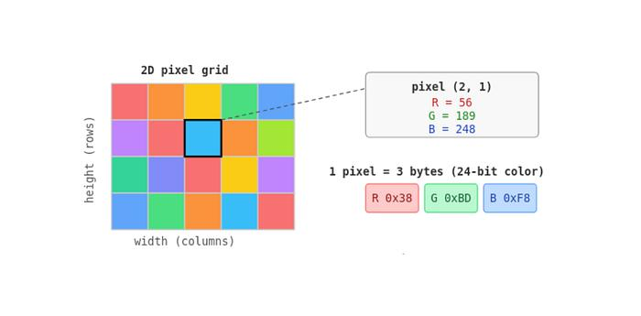
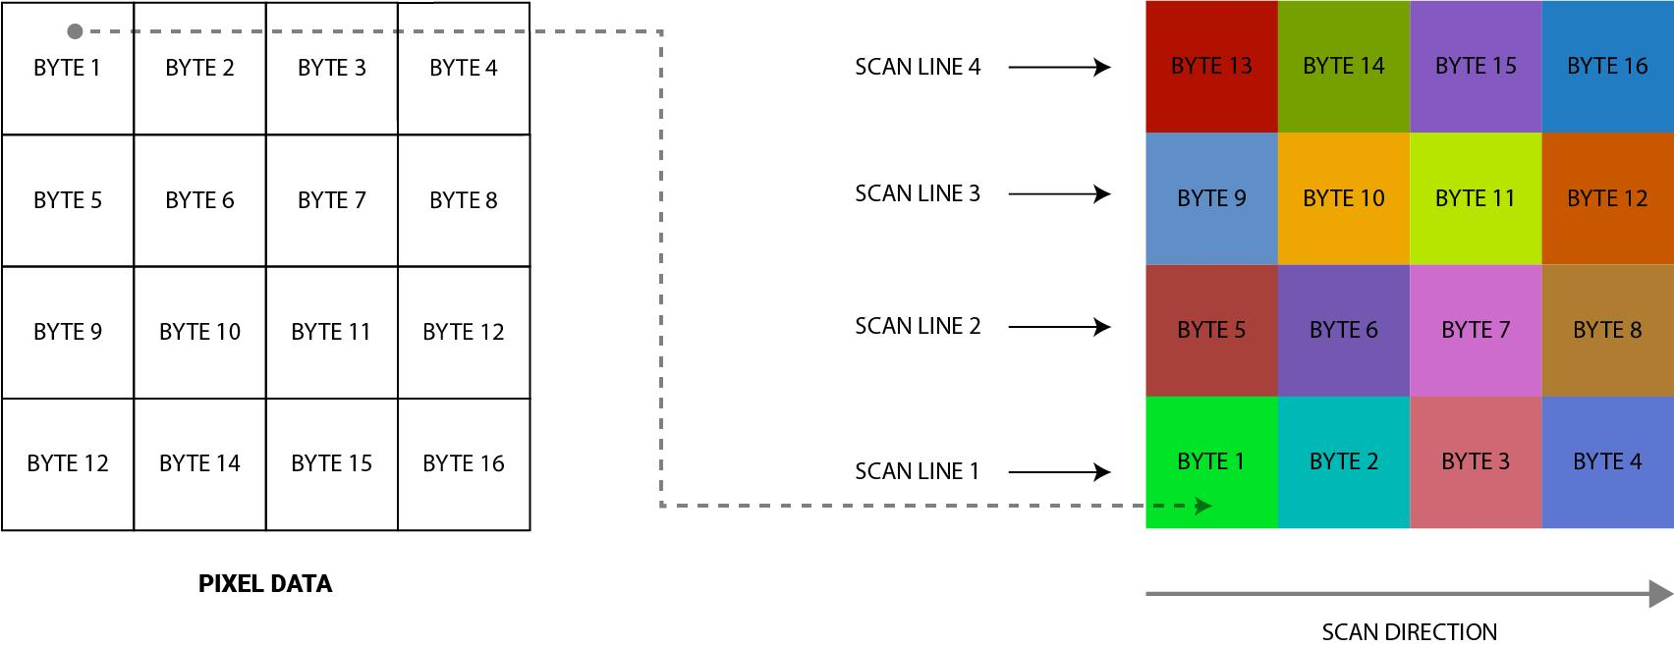
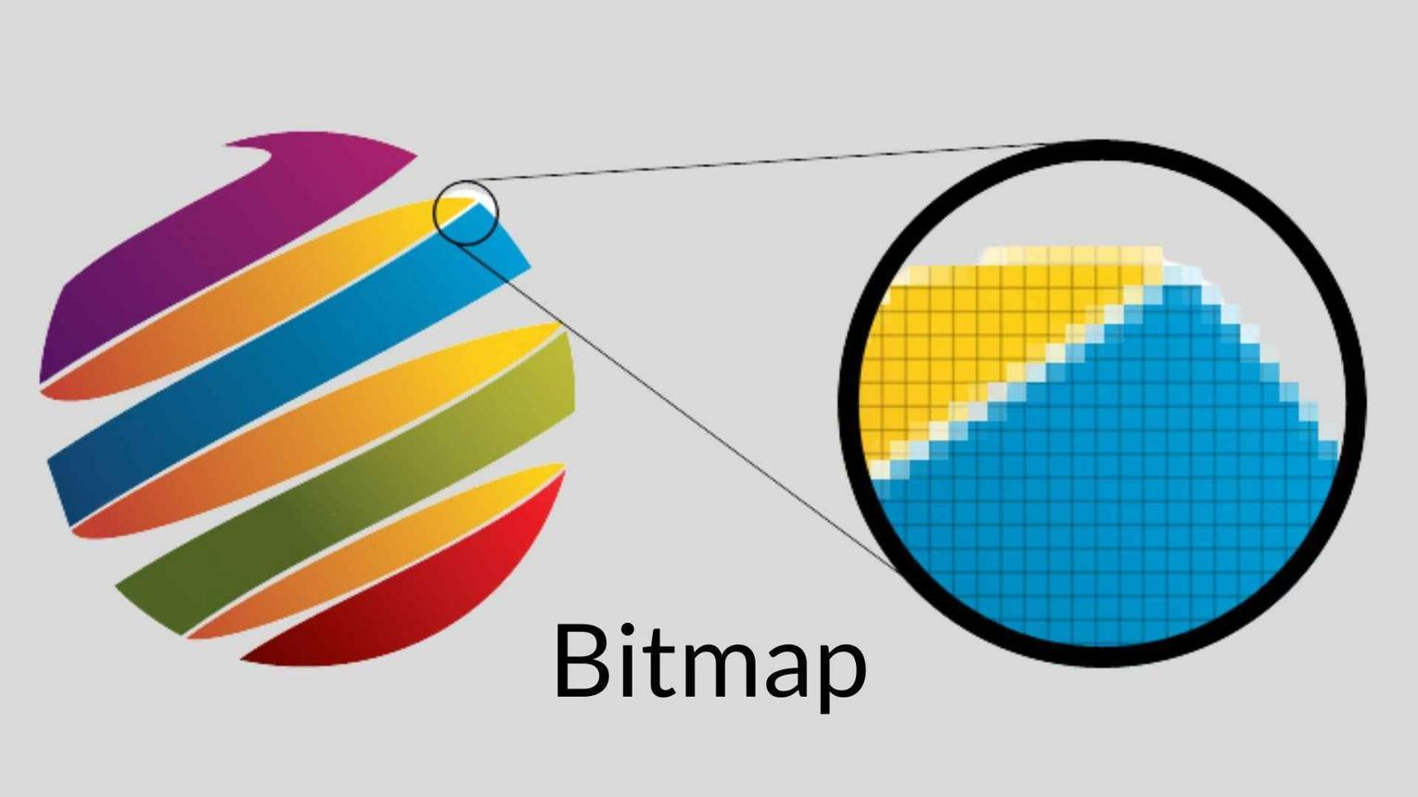
- Image is made of tiny pixels (dots)
- Each pixel stores a specific color value
- No or very little compression is used
- Image is stored pixel-by-pixel

🧠 Simple example
# Source: AI Source: Provided by: [Data Path: Persons Table -> ID Column: 1, Name_En Column: Motasem Essam] -> From: [ChatGPT] on [5/2/2026]
Think of:
- 🧩 A mosaic made of colored tiles
- 🖥️ A screen showing raw pixel colors
- 🎨 A very basic image with no optimization

🎮 Where BMP is used
# Source: AI Source: Provided by: [Data Path: Persons Table -> ID Column: 1, Name_En Column: Motasem Essam] -> From: [ChatGPT] on [5/2/2026]
- 🧑‍💻 Basic image processing
- 💻 Windows system graphics (old applications)
- 🧪 Educational purposes in computer graphics
- 🧩 Simple pixel-based editing

⚙️ Key features
# Source: AI Source: Provided by: [Data Path: Persons Table -> ID Column: 1, Name_En Column: Motasem Essam] -> From: [ChatGPT] on [5/2/2026]
- 🟡 High quality but very large file size
- 🧱 Pixel-by-pixel storage
- 🚫 Usually no compression
- ⚡ Fast to read/write, but inefficient storage

🚀 In short:
# Source: AI Source: Provided by: [Data Path: Persons Table -> ID Column: 1, Name_En Column: Motasem Essam] -> From: [ChatGPT] on [5/2/2026]
BMP = a basic image format that stores images as raw pixels, giving high quality but large file size.

